# Logging in to Naviance (Staff and Students)

## Go to https://launchpad.classlink.com/cbsd

1. 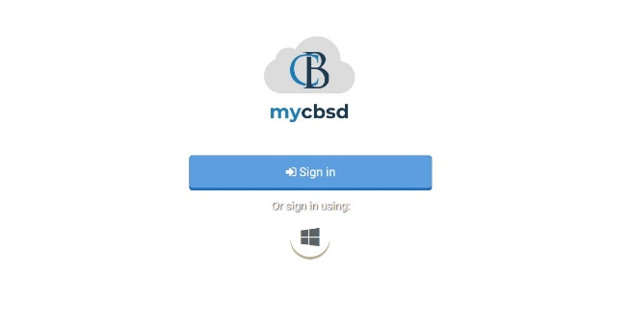Click the **Sign In button**
2. Enter your @CBSD.org staff email address, and password and click **Sign In**
3. Click on the **Naviance Icon**

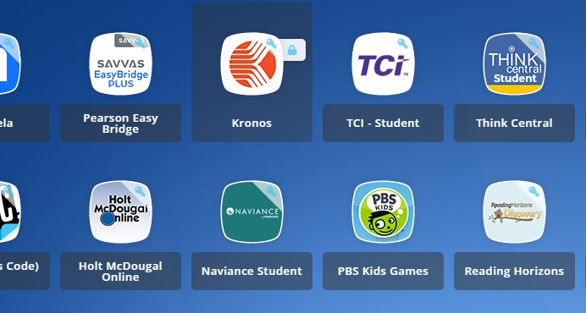

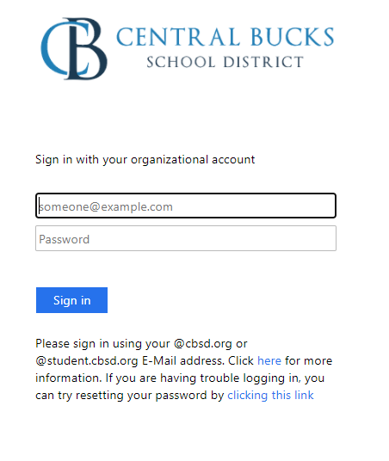You will then be logged into Naviance.

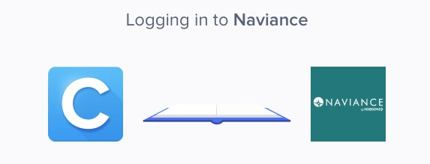



Tenth Grade Scope and Sequence

# Complete the Career Interest Profiler

1. From your Naviance Student homepage, click

**My Planner** and then **Tasks** in the top right corner

1. From the Task page, click the task titled

## Complete Career Interest Profiler

1. Locate the “completion trigger” in the top

right corner indicated by the pink arrow



1. Click the text, **complete the Career Interest Profiler** to go to the assessment page
2. On the Career Interest Profiler assessment screen, read over the directions. When you’re ready to begin, click **start assessment** at the top of the screenGraphical user interface, text, application, chat or text message

   Description automatically generated
3. On each page, mark ifthe activity or job listed is like you by clicking **strongly disagree, disagree neutral, agree, or strongly agree**.

1. Clicking an answer will make the page automatically move the to the next question. The final question will take you to your results page.
2. Viewing your results marks the task as complete! Remember to click the heart icon to save top career clusters to your favorites page.

# Career Interest Profiler Reflection Survey

1. From your Naviance Student homepage, click **My Planner** and then **Tasks** in the top right corner.

1. Locate the “completion trigger” in the top

right corner indicated by the pink arrow.



* 1. Click the text, **complete the Career Interest Profiler Reflection Survey** to go to the survey page.
  2. Once you have answered all of the required questions (marked by an asterisk and in red) click “Submit Answers” at the bottom of the page.



# Complete StrengthsExplorer Assessment

1. From your Naviance Student homepage, click **My Planner** and then **Tasks** in the top right corner. Graphical user interface, website

   Description automatically generated

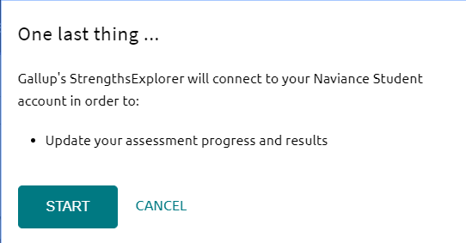

6. On each page, select if the bolded statement describes you “Almost Always (or Always),” “Often,” “Sometimes,” “Almost Never (or Never),” or “The Question Does Not Make Sense to Me”.

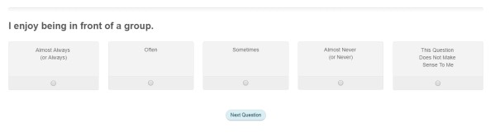

1. From the Task page, click the task titled

## Complete StrengthsExplorer.

1. Locate the “completion trigger” in the top right corner indicated by the pink arrow.



1. Click the text, **complete the StrengthsExplorer assessment** to go to the assessment page.
2. On the StrengthsExplorer assessment screen, read over the directions. When you’re ready to begin, click **take assessment** at the bottom of the screen. Check the boxes in the pop-up window and click **I got it** then **start** to continue.

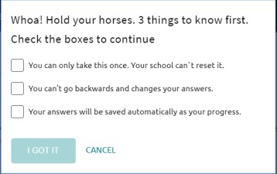

1. Click **Next Question** to continue.
2. Viewing your results marks the task as complete! Remember to click the heart icon to save top career pathways to your favorites page.

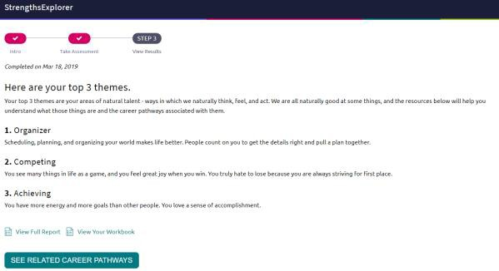

# StrengthsExplorer Reflection Survey

1. From your Naviance Student homepage, click **My Planner** and then **Tasks** in the top right corner.

1. Locate the “completion trigger” in the top

right corner indicated by the pink arrow.



1. Click the text, **complete the StrengthsExplorer Reflection Survey** to go to the survey page.
   1. Once you have answered all of the required questions (marked by an asterisk and in red) click “Submit Answers” at the bottom of the page.



# Complete the Achieve Works Skills Survey

1. From your Naviance Student homepage, click **Self Discover** and then **Skills** Graphical user interface, text, application, chat or text message

   Description automatically generated
2. Read over the instructions and click **Start Assessment** when you are ready to being

1. Answer from 1 to 6 if you think each statement is like you. The questions will auto-progress once you make your selection.

1. Your final answer will bring you to your results page. This is how you know you’ve completed the assessment

# Achieve Works Skills Survey

1. From your Naviance Student homepage, click **My Planner** and then **Tasks** in the top right corner.

1. Locate the “completion trigger” in the top

right corner indicated by the pink arrow.



1. Click the text, **complete the AchieveWorks Skill Reflection Survey** to go to the survey page.
   1. Once you have answered all of the required questions (marked by an asterisk and in red) click “Submit Answers” at the bottom of the page.



# Begin Resume Building

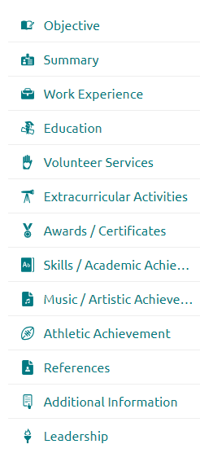

1. From your Naviance Student homepage, click **My Planner** and then **Tasks** in the top right corner.

1. From the Task page, click the task titled **Build Resume.**
2. Locate the “completion trigger” in the top

right corner indicated by the pink arrow.



1. Click the text, **build a resume** to go to the Resume Builder tool.
2. On the Resume Builder page, click the pink circle and white arrow to add a section to your resume.



You can add experiences from the following areas:

1. Add your information into the resume area you selected. When you are finished with each section click **Add.**
2. Once you’ve added all the sections you would like in this draft of your resume, click **Print/Export Resume** at the top of the screen.



1. Clicking the same pink circle and white arrow icon, add a resume draft. Name your draft and select a resume template.

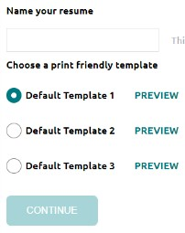

1. Select the resume sections you’d like to include in your draft using the check boxes. When complete click **Save Resume.**
2. A completed draft of your resume marks the task as completed